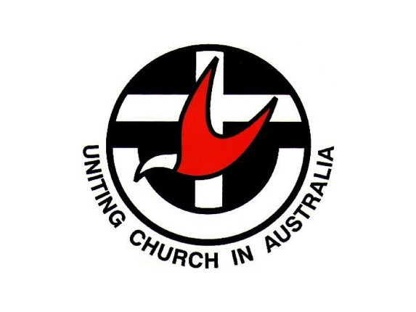
PRESBYTERY OF
NORTH EAST VICTORIA

WANDILIGONG
YOUTH AND CHILDREN'S
MINISTRY FUND

GRANT APPLICATION FORM

February 2020

PREAMBLE:
The Wandiligong Youth and Children's Ministry Fund was established from the sale proceeds of the Wandiligong Camp. As this camp was established from the vision of men and women who had a passion for ministry with youth and children, this ministry fund was established to enable congregations and other groups within the Goulburn-Murray Presbytery to undertake innovative ministry with youth and children.
With the changes to Presbytery boundaries, this fund is now available to all congregations and Faith Communities in the Presbytery of North East Victoria to support ministry with youth and children.
Examples of uses to which the fund may be applied include:
· Equipment for camping programs
· Subsidy for travel to distant events
· Resources for worship enabling the participation of youth and children
· Establishment and maintenance of communication networks
· Establishment of outreach ministries (coffee shops, Advent workshops, after school/holiday clubs)
· Building presbytery resources
· Equipment for camping and other presbytery programs
PROCESS:
Congregations of the Presbytery of North East Victoria, along with the Committee for Ministry with Youth, Children and Families are invited to submit applications for innovative programs.
These applications will clearly indicate the ways in which the money is to be used, the vision behind the ministry, and the support for the Ministry within the sponsoring body.
All applications must be submitted using Application Forms which are available from the Contact People below. Where possible, in addition to sending the original signed application by mail, we would like applications to be emailed to facilitate circulation to the Wandi Committee.
CONTACT PERSON:
Mission and Education Committee: Secretary: Joan McRae joanmcr@netspace.net.au or
Chair: Rev Brian Spencer brianspencer@wrangaunitingchurches.voc.au
DEADLINE FOR APPLICATIONS:
There will be two rounds of funding each year. Applications will close on 31st March and 30th September, with successful funding applications announced at the following Presbytery meetings
PLEASE NOTE:
All sections of this form must be completed. Incomplete forms will be returned.
If there are more applications received in any round of funding than the money available then preference may be given to those grants where a financial contribution towards the project is made by the applying body.

Wandiligong Youth and Children’s Ministry Fund Application Page

Applicant Name: __________________________________________________
Contact Details Email ......................................................... Phone .....................
Activity/Project Name:______________________________________________
On Behalf of (Congregation):______________________________________
Ministry Objective and Outreach
In a few sentences, please outline what you are seeking the funds for and how it forms part of your Youth and Children’s Ministry Outreach: ________________________________________________________________________________________________________________________________________________________________________________________________________________________________________________________________________________________________________________________________________________________________________________________________________________
Which of these best defines your project? (Tick one or more boxes)
A one-off even
Just trying something new (it may or may not end up being on-going)
Equipment or Resources
Other (please define)
An ongoing mission outreach
_______________________________________________________________
Which of these best describes your project? (Tick all that relate)
A community building exercise
A children’s project
A youth project
A family project
A children’s/youth/family camp
Any further information ________________________________________________________________
Does this project have the support of the church council (or other relevant body) Yes / No (Please circle)
Please provide the name and phone number of the church council (or other) representative:
________________________________________________________________
How much are you seeking from the fund? $__________ (The maximum offered is $1,500)
How much are you (if any) contributing toward the project? $__________
Will this event/project proceed if we are unable to offer the amount you are seeking? Yes / No (Please circle)
If No, what is the minimum you need to make it happen? $___________
Please list the key items/activities and their estimated cost:
_______________________________________________________________________________________________________________________________________________________________________________________________________________
Do you have any other community support for this project? If so, what?
_____________________________________________________________________
Are there any other participants in this project? (Other churches/agencies etc)

How will the project be managed? (What are the accountability arrangements?) _____________________________________________________________________________________________________________________________
Have you completed the Synod Safety and Compliance Form yet? Yes/No
Are there any other details you would like to share about the project?
_______________________________________________________________________________________________________________________________________________________________________________________________________________
(Feel free to add any supporting evidence that may assist the Mission and Education Committee to make its decision)

